**DAA ASSIGNMENT-2**



**SUBMITTED TO:**

**PROF. SUBHASH TATALE**

**VISHWAKARMA INSTITUTE OF INFORMATION TECHNOLOGY, PUNE**

**COMPUTER ENGINEERING DEPARTMENT**

**BY:**

**NAME: ABHISHEK MORE**

**G.R NO.: 21810033**

**ROLL NO.: 323036**

**CLASS: T.Y COMP**

**BATCH: COMP C2**

**Assignment-2**

**Aim:**

Implement Job Scheduling using Greedy algorithm.

**Objective:**

Our objective is to learn the implementation of Greedy algorithm by performing Job Scheduling to schedule the given jobs in such a way that they give maximum profit or we can say the optimal solution.

**What is Greedy algorithm?**

Greedy is an algorithmic paradigm that builds up a solution piece by piece, always choosing the next piece that offers the most obvious and immediate benefit.

**Source code:**

**package** assignment2_jobScheduling;

**import** java.util.*;

**public** **class** JobScheduling

{

@SuppressWarnings("resource")

**public** **static** **void** main(String args[])

{

Scanner sc=**new** Scanner(System.***in***);

System.***out***.println("Enter the number of Jobs");

**int** n=sc.nextInt();

String a[]=**new** String[n];

**int** b[]=**new** **int**[n];

**int** c[]=**new** **int**[n];

System.***out***.println("\nEnter the Job, profit and then deadline for each job.");

**for**(**int** i=0;i<n;i++)

{

a[i]=sc.next();

b[i]=sc.nextInt();

c[i]=sc.nextInt();

**if**(c[i] <= 0)

{

System.***out***.println("\nDeadline should be greater than '0'. Please enter again!");

c[i]=sc.nextInt();

}

}

System.***out***.println("\nOrder in which jobs are entered.");

System.***out***.println("Jobs Profit Deadline");

**for**(**int** i=0;i<n;i++)

{

System.***out***.print(a[i]+"\t");

System.***out***.print(b[i]+"\t");

System.***out***.print(c[i]+"\t");

System.***out***.println();

}

**for**(**int** i=0;i<n-1;i++)

{

**for**(**int** j=i+1;j<n;j++)

{

**if**(b[i]<b[j])

{

**int** temp=b[i];

b[i]=b[j];

b[j]=temp;

temp=c[i];

c[i]=c[j];

c[j]=temp;

String strTemp=a[i];

a[i]=a[j];

a[j]=strTemp;

}

}

}

System.***out***.println();

System.***out***.println("Sorted job order");

System.***out***.println("Jobs Profit Deadline");

**for**(**int** i=0;i<n;i++)

{

System.***out***.print(a[i]+"\t");

System.***out***.print(b[i]+"\t");

System.***out***.print(c[i]+"\t");

System.***out***.println();

}

**int** max=c[0];

**for**(**int** i=0;i<n;i++)

{

**if**(c[i]>max)

{

max=c[i];

}

}

String jExec[]=**new** String[max];

**int** profit=0;

**for**(**int** i=0;i<n;i++)

{

**int** previous=c[i];

--previous;

**if**(jExec[previous]==**null**)

{

jExec[previous]=a[i];

profit+=b[i];

}

**else**

{

**while**(previous != -1)

{

**if**(jExec[previous]==**null**)

{

jExec[previous]=a[i];

profit+=b[i];

**break**;

}

--previous;

}

}

}

System.***out***.print("\nJob execution order is: ");

**for**(**int** i=0;i<max;i++)

{

System.***out***.print(jExec[i] + " ");

}

System.***out***.println();

System.***out***.print("Total profit Earned: "+profit);

}

}

**Output:**

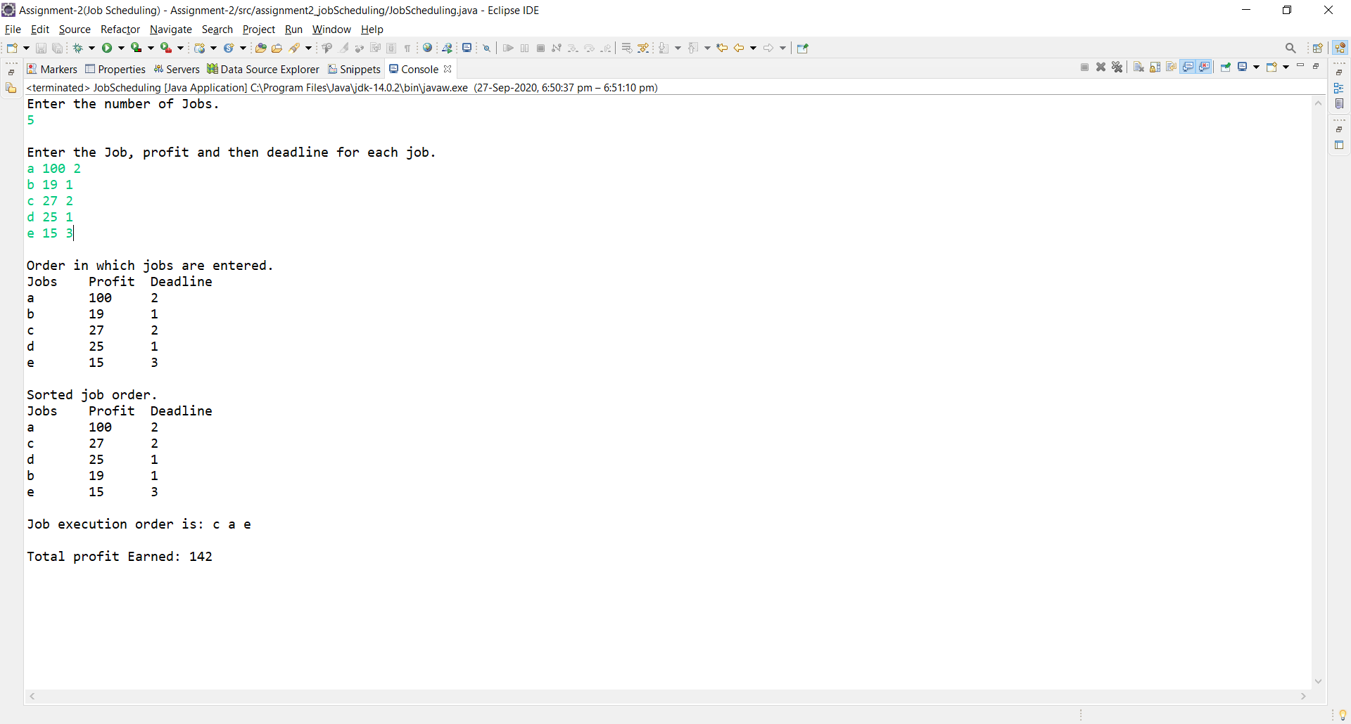

**Conclusion:**

Learnt how Greedy algorithm optimizes the solution by successfully implementing the Job Scheduling problem.